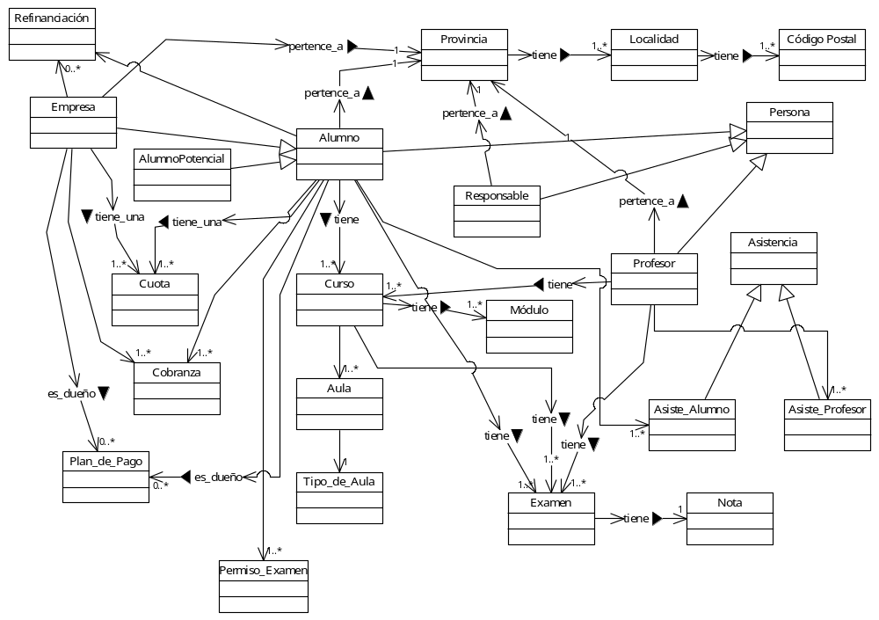
0..*
1..*
Correlativa
0..*
0..*

